- Облік основних засобів.
- Вихідні документи.
- Реєстр зміни вартості.
- Розрахунок.
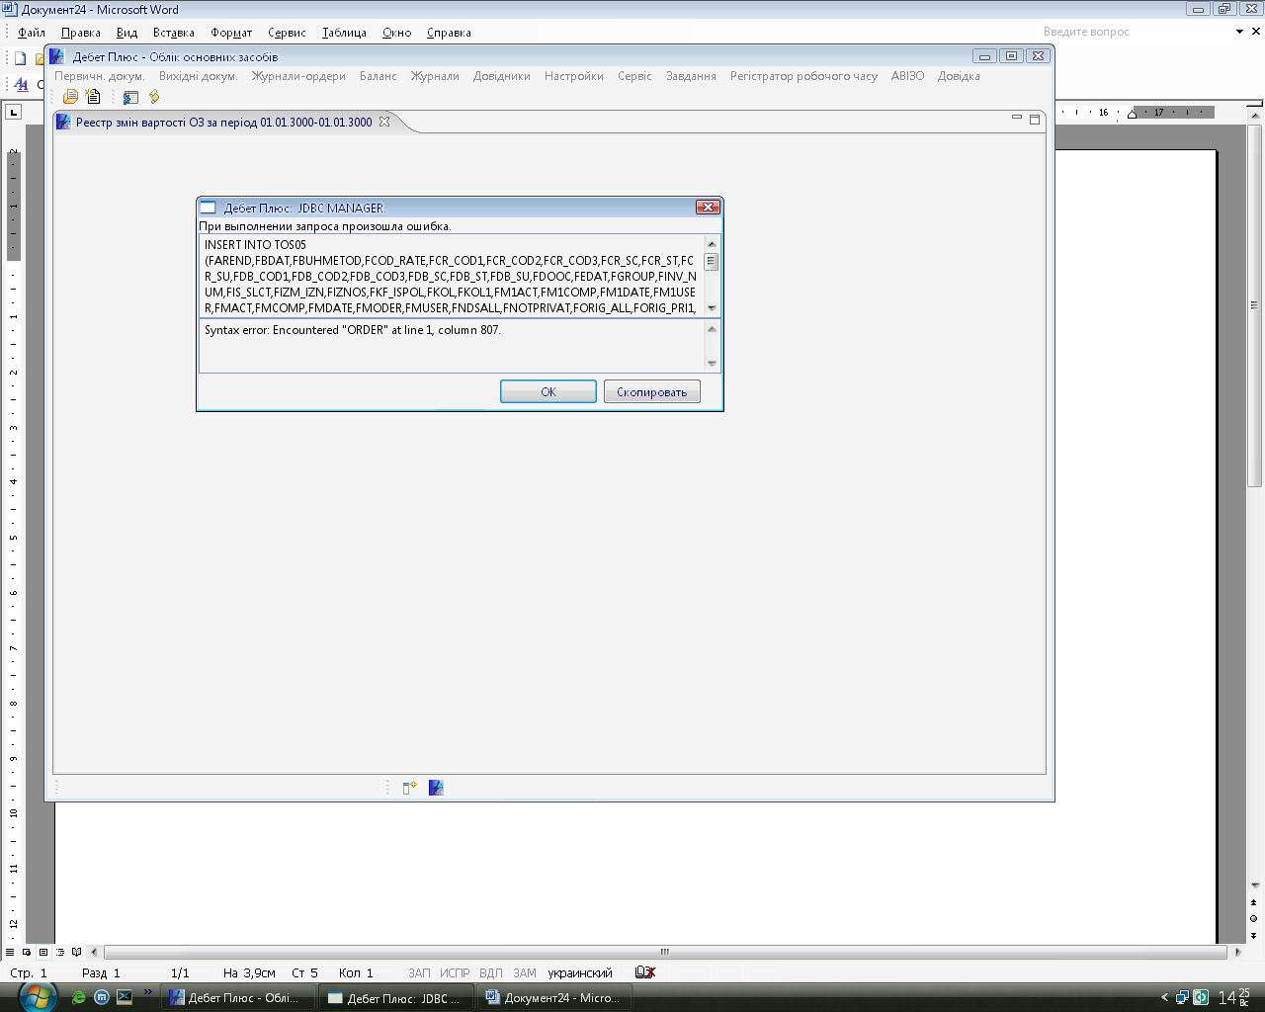
INSERT INTO TOS05 (FAREND,FBDAT,FBUHMETOD,FCOD_RATE,FCR_COD1,FCR_COD2,FCR_COD3,FCR_SC,FCR_ST,FCR_SU,FDB_COD1,FDB_COD2,FDB_COD3,FDB_SC,FDB_ST,FDB_SU,FDOOC,FEDAT,FGROUP,FINV_NUM,FIS_SLCT,FIZM_IZN,FIZNOS,FKF_ISPOL,FKOL,FKOL1,FM1ACT,FM1COMP,FM1DATE,FM1USER,FMACT,FMCOMP,FMDATE,FMODER,FMUSER,FNDSALL,FNOTPRIVAT,FORIG_ALL,FORIG_PRI1,FORIG_PRIC,FOST07,FOUTID,FSROKADD,FWID) SELECT FAREND,FBDAT,FBUHMETOD,FCOD_RATE,FCR_COD1,FCR_COD2,FCR_COD3,FCR_SC,FCR_ST,FCR_SU,FDB_COD1,FDB_COD2,FDB_COD3,FDB_SC,FDB_ST,FDB_SU,FDOOC,FEDAT,FGROUP,FINV_NUM,FIS_SLCT,FIZM_IZN,FIZNOS,FKF_ISPOL,FKOL,FKOL1,FM1ACT,FM1COMP,FM1DATE,FM1USER,FMACT,FMCOMP,FMDATE,FMODER,FMUSER,FNDSALL,FNOTPRIVAT,FORIG_ALL,FORIG_PRI1,FORIG_PRIC,FOST07,FOUTID,FSROKADD,FWID from DPBASE.uos_OS0 where Fbdat<='2006-12-31 00:00:00' or Fedat>='2006-1-1 00:00:00' ORDER by Finv_num, Fbdat, Fedat

