- Облік ТМЦ.
- Баланс.
- Відомість-16.

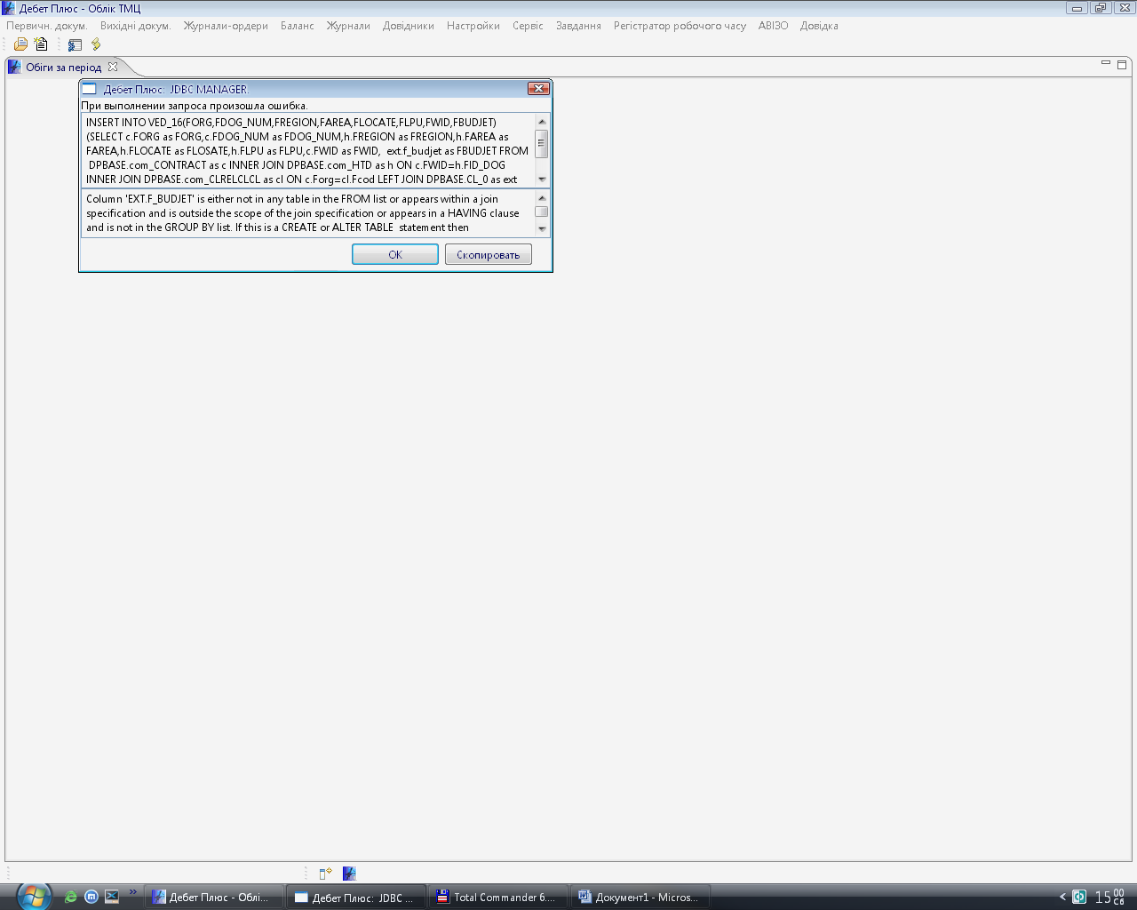
INSERT INTO VED_16(FORG,FDOG_NUM,FREGION,FAREA,FLOCATE,FLPU,FWID,FBUDJET) (SELECT c.FORG as FORG,c.FDOG_NUM as FDOG_NUM,h.FREGION as FREGION,h.FAREA as FAREA,h.FLOCATE as FLOSATE,h.FLPU as FLPU,c.FWID as FWID, ext.f_budjet as FBUDJET FROM DPBASE.com_CONTRACT as c INNER JOIN DPBASE.com_HTD as h ON c.FWID=h.FID_DOG INNER JOIN DPBASE.com_CLRELCLCL as cl ON c.Forg=cl.Fcod LEFT JOIN DPBASE.CL_0 as ext ON ext.Fmainwid=cl.fwid_cl WHERE c.FBDAT>='2006-1-1 00:00:00' AND c.FEDAT<='2006-12-31 00:00:00' AND cl.Fcl=12)

