- Облік ТМЦ.
- Вихідні документи.
- Карта складського обліку.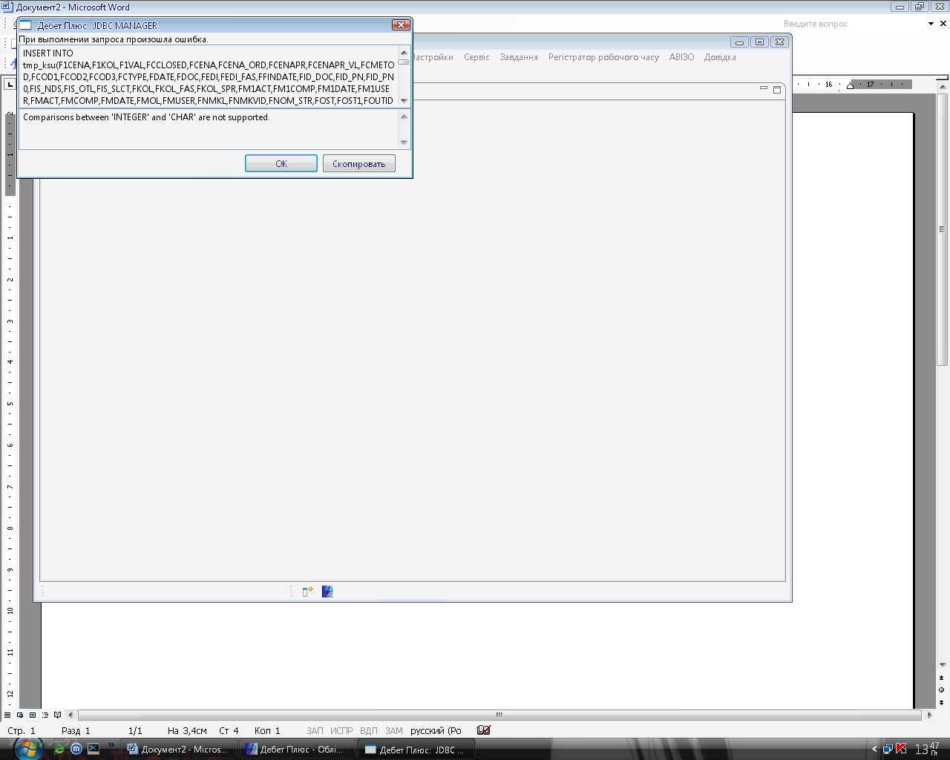
INSERT INTO tmp_ksu(F1CENA,F1KOL,F1VAL,FCCLOSED,FCENA,FCENA_ORD,FCENAPR,FCENAPR_VL,FCMETOD,FCOD1,FCOD2,FCOD3,FCTYPE,FDATE,FDOC,FEDI,FEDI_FAS,FFINDATE,FID_DOC,FID_PN,FID_PN0,FIS_NDS,FIS_OTL,FIS_SLCT,FKOL,FKOL_FAS,FKOL_SPR,FM1ACT,FM1COMP,FM1DATE,FM1USER,FMACT,FMCOMP,FMDATE,FMOL,FMUSER,FNMKL,FNMKVID,FNOM_STR,FOST,FOST1,FOUTID,FPODR,FPOST,FRTYPE,FSC,FSC1,FST,FST1,FSU,FSU1,FSUM,FVAL,FVCENA,FVCOD,FWID,FWID_CH,ftt,fnop,frkolR,frkolV,fpkolR,fpkolV,fekol,frkolR_spr,frkolV_spr,fpkolR_spr,fpkolV_spr,fekol_spr,fesum,frsumR,frsumV,fpsumR,fpsumV) SELECT a.F1CENA,a.F1KOL,a.F1VAL,a.FCCLOSED,a.FCENA,a.FCENA_ORD,a.FCENAPR,a.FCENAPR_VL,a.FCMETOD,a.FCOD1,a.FCOD2,a.FCOD3,a.FCTYPE,a.FDATE,a.FDOC,a.FEDI,a.FEDI_FAS,a.FFINDATE,a.FID_DOC,a.FID_PN,a.FID_PN0,a.FIS_NDS,a.FIS_OTL,a.FIS_SLCT,a.FKOL,a.FKOL_FAS,a.FKOL_SPR,a.FM1ACT,a.FM1COMP,a.FM1DATE,a.FM1USER,a.FMACT,a.FMCOMP,a.FMDATE,a.FMOL,a.FMUSER,a.FNMKL,a.FNMKVID,a.FNOM_STR,a.FOST,a.FOST1,a.FOUTID,a.FPODR,a.FPOST,a.FRTYPE,a.FSC,a.FSC1,a.FST,a.FST1,a.FSU,a.FSU1,a.FSUM,a.FVAL,a.FVCENA,a.FVCOD,a.FWID,a.FWID_CH,'BB' as ftt, B.fnop as fnop, (CASE WHEN frtype= '7' THEN a.fkol ELSE 0 END) AS frkolR, (CASE WHEN frtype= '8' THEN a.fkol ELSE 0 END) AS frkolV, (CASE WHEN frtype= '5' THEN a.fkol ELSE 0 END) AS fpkolR, (CASE WHEN frtype= '6' THEN a.fkol ELSE 0 END) AS fpkolV, DOUBLE(0) as fekol, (CASE WHEN frtype= '7' THEN fkol_spr ELSE 0 END) AS frkolR_spr, (CASE WHEN frtype= '8' THEN fkol_spr ELSE 0 END) AS frkolV_spr, (CASE WHEN frtype= '5' THEN fkol_spr ELSE 0 END) AS fpkolR_spr, (CASE WHEN frtype= '6' THEN fkol_spr ELSE 0 END) AS fpkolV_spr, DOUBLE(0) as fekol_spr, DOUBLE(0) as fesum, (CASE WHEN frtype= '7' THEN a.fkol ELSE 0 END)*fcena AS frsumR, (CASE WHEN frtype= '8' THEN a.fkol ELSE 0 END)*fcena AS frsumV, (CASE WHEN frtype= '5' THEN a.fkol ELSE 0 END)*fcena AS fpsumR, (CASE WHEN frtype= '6' THEN a.fkol ELSE 0 END)*fcena AS fpsumV FROM DPBASE.mtr_anltk A LEFT JOIN DPBASE.mtr_sch_zag B ON A.fid_doc=B.fwid WHERE A.Fdate BETWEEN '2006-9-21 00:00:00' AND '2006-12-31 00:00:00' AND frtype<> '1' AND a.fdoc<>'SF' and A.Fnmkl= '23931'

