- Облік касових операцій.
- Реєстр квитанцій. 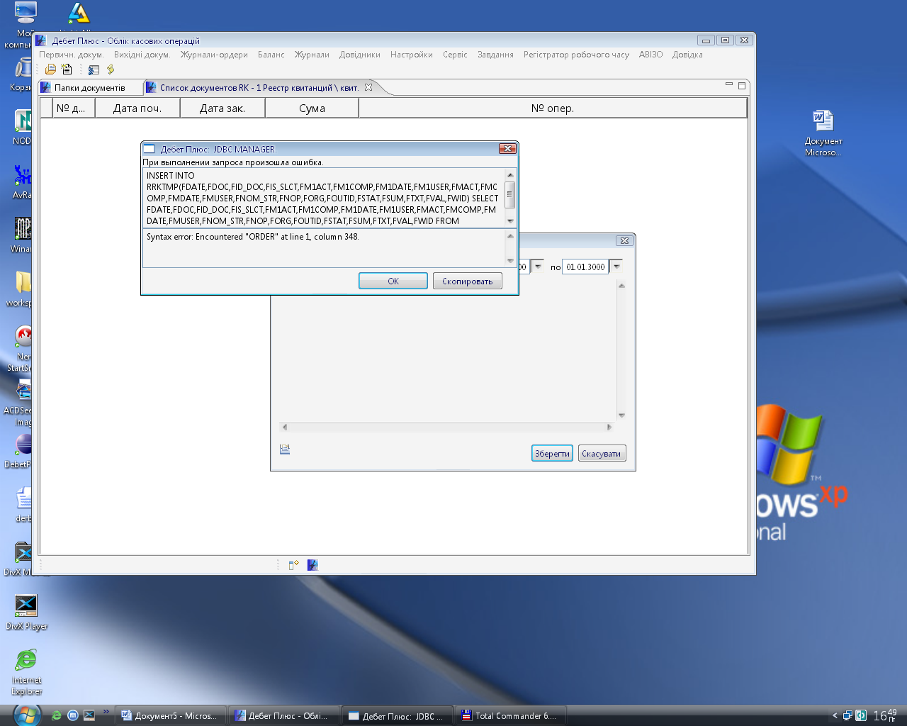
INSERT INTO RRKTMP(FDATE,FDOC,FID_DOC,FIS_SLCT,FM1ACT,FM1COMP,FM1DATE,FM1USER,FMACT,FMCOMP,FMDATE,FMUSER,FNOM_STR,FNOP,FORG,FOUTID,FSTAT,FSUM,FTXT,FVAL,FWID) SELECT FDATE,FDOC,FID_DOC,FIS_SLCT,FM1ACT,FM1COMP,FM1DATE,FM1USER,FMACT,FMCOMP,FMDATE,FMUSER,FNOM_STR,FNOP,FORG,FOUTID,FSTAT,FSUM,FTXT,FVAL,FWID FROM DPBASE.cas_RRK WHERE fid_doc = '23998' ORDER BY FNOM_STR

