- Облік касових операцій.
- Відомості до журналів-ордерів в розрізі рахунків.
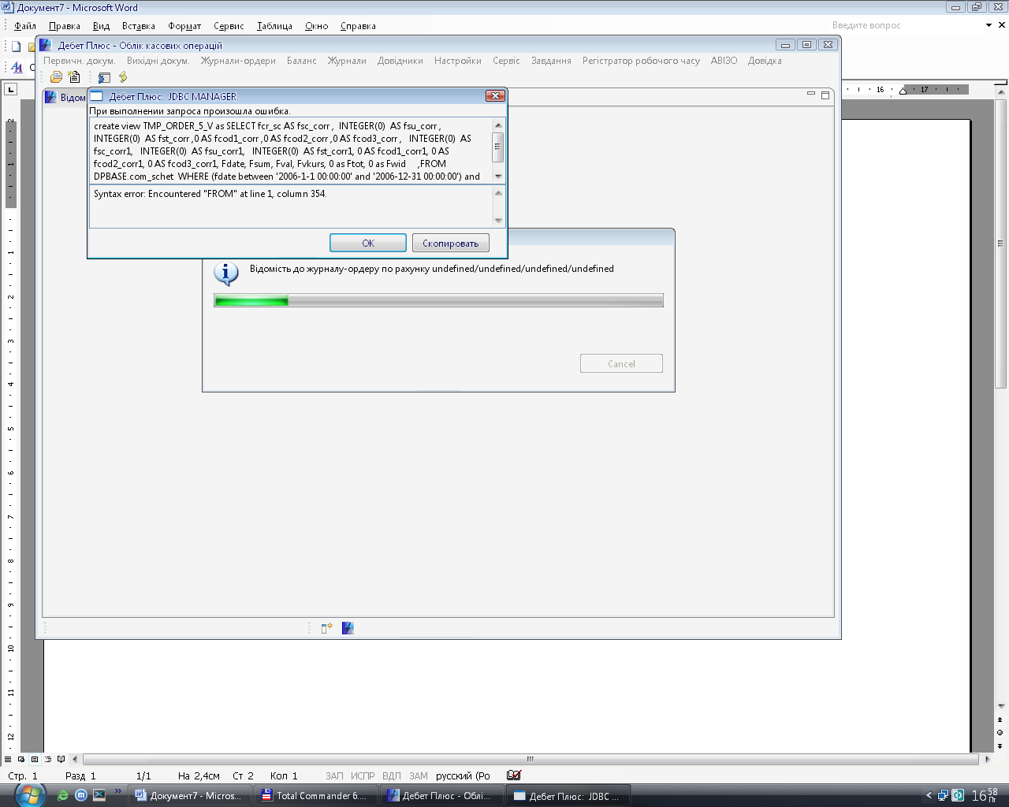
create view TMP_ORDER_5_V as SELECT fcr_sc AS fsc_corr , INTEGER(0) AS fsu_corr , INTEGER(0) AS fst_corr ,0 AS fcod1_corr ,0 AS fcod2_corr ,0 AS fcod3_corr , INTEGER(0) AS fsc_corr1, INTEGER(0) AS fsu_corr1, INTEGER(0) AS fst_corr1, 0 AS fcod1_corr1, 0 AS fcod2_corr1, 0 AS fcod3_corr1, Fdate, Fsum, Fval, Fvkurs, 0 as Ftot, 0 as Fwid ,FROM DPBASE.com_schet WHERE (fdate between '2006-1-1 00:00:00' and '2006-12-31 00:00:00') and fdb_sc = 30 and fwrk<>16 and fval <>0 as o0 FROM

