1. DebetPlus 11.5.01 RC2, MySQL.
2. BS 4.
3. INS.

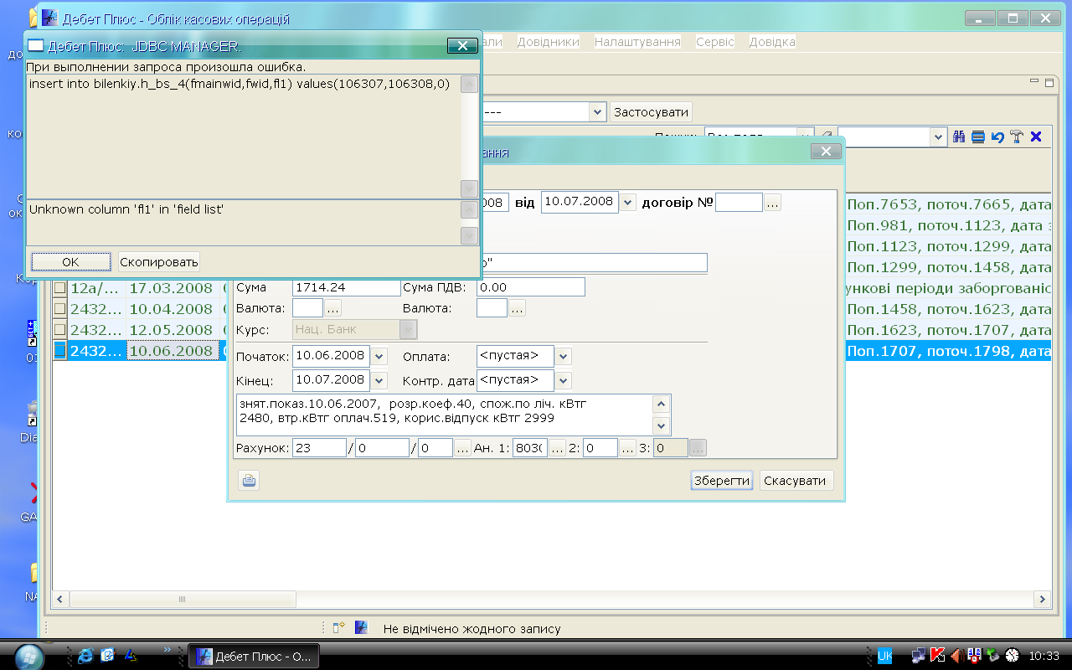
insert into bilenkiy.h_bs_4(fmainwid,fwid,fl1) values(106307,106308,0)

