- Облік кадрів.
- Кадри.
- Особові справи.
- Що працюють.
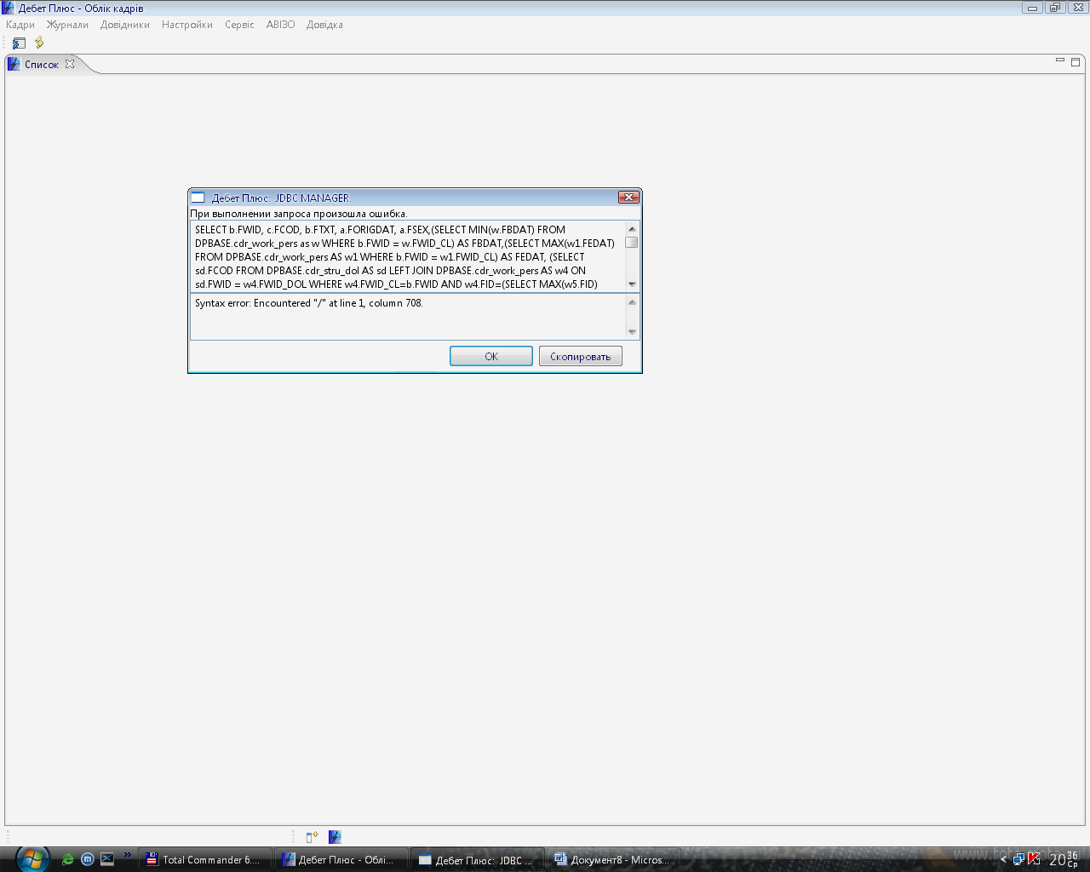

SELECT b.FWID, c.FCOD, b.FTXT, a.FORIGDAT, a.FSEX,(SELECT MIN(w.FBDAT) FROM DPBASE.cdr_work_pers as w WHERE b.FWID = w.FWID_CL) AS FBDAT,(SELECT MAX(w1.FEDAT) FROM DPBASE.cdr_work_pers AS w1 WHERE b.FWID = w1.FWID_CL) AS FEDAT, (SELECT sd.FCOD FROM DPBASE.cdr_stru_dol AS sd LEFT JOIN DPBASE.cdr_work_pers AS w4 ON sd.FWID = w4.FWID_DOL WHERE w4.FWID_CL=b.FWID AND w4.FID=(SELECT MAX(w5.FID) FROM DPBASE.cdr_work_pers AS w5 WHERE w5.FWID_CL=b.FWID)) AS FKOD_DOL, (SELECT sd.FOKLAD FROM DPBASE.cdr_stru_dol AS sd LEFT JOIN DPBASE.cdr_work_pers AS w4 ON sd.FWID = w4.FWID_DOL WHERE w4.FWID_CL=b.FWID AND w4.FID=(SELECT MAX(w5.FID) FROM DPBASE.cdr_work_pers AS w5 WHERE w5.FWID_CL=b.FWID)) AS FOKLAD,FLOOR(null/365) AS FSENIORITY FROM (DPBASE.com_cl AS b INNER JOIN DPBASE.com_clrelclcl AS c ON b.FWID = c.FWID_CL) INNER JOIN DPBASE.com_cl_homo AS a ON b.FWID = a.FWID_CL WHERE (((c.FCL=0) AND ((((SELECT MAX(w1.FEDAT) FROM DPBASE.cdr_work_pers AS w1 WHERE b.FWID = w1.FWID_CL) = '3000-01-01 00:00:00' ) OR (( NOT (SELECT MIN(w.FBDAT) FROM DPBASE.cdr_work_pers as w WHERE b.FWID = w.FWID_CL) IS NULL) AND ( NOT (SELECT MAX(w1.FEDAT) FROM DPBASE.cdr_work_pers AS w1 WHERE b.FWID = w1.FWID_CL) IS NULL)))))) ORDER BY FCOD

