- Накази.
- На призначення.
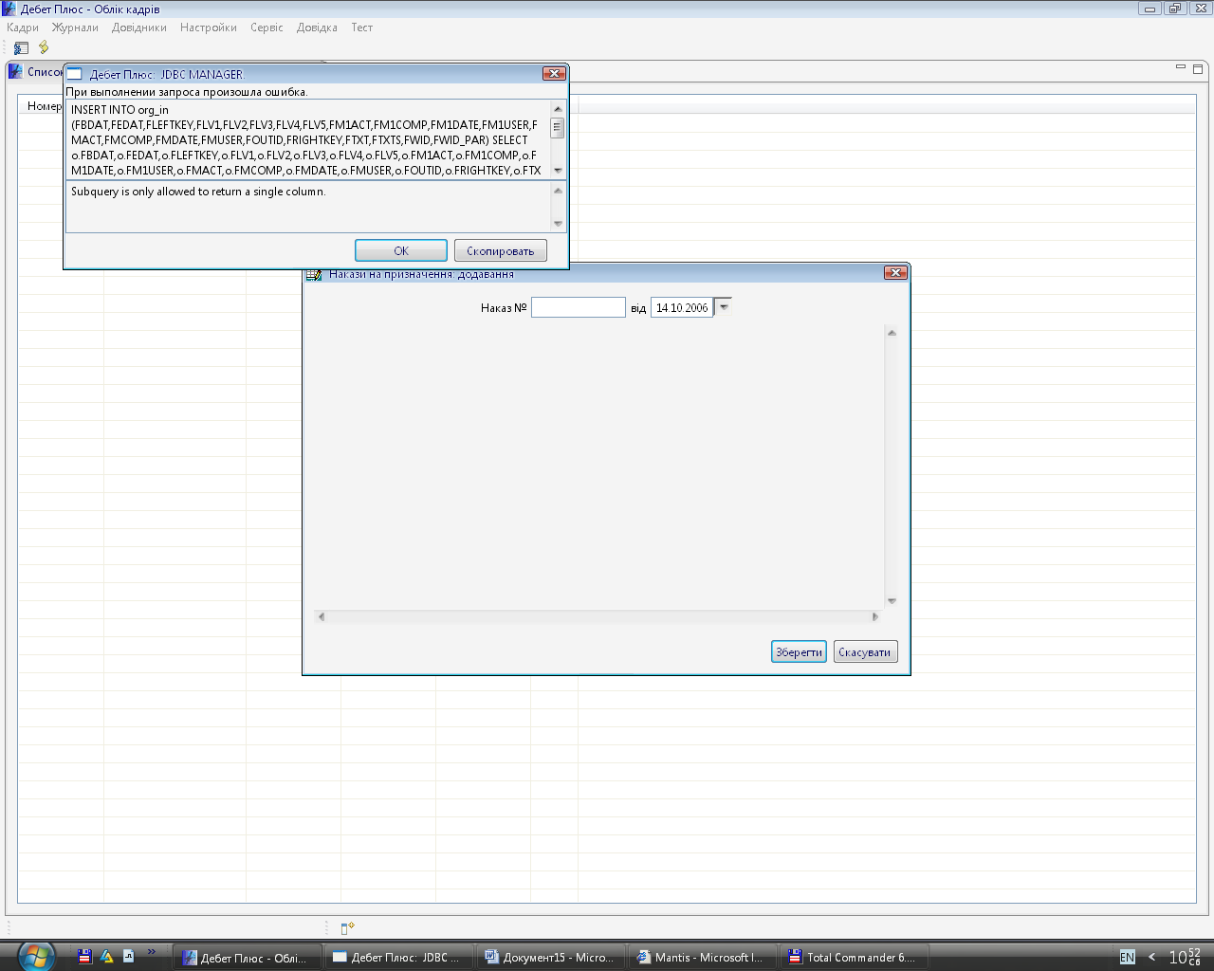
INSERT INTO org_in (FBDAT,FEDAT,FLEFTKEY,FLV1,FLV2,FLV3,FLV4,FLV5,FM1ACT,FM1COMP,FM1DATE,FM1USER,FMACT,FMCOMP,FMDATE,FMUSER,FOUTID,FRIGHTKEY,FTXT,FTXTS,FWID,FWID_PAR) SELECT o.FBDAT,o.FEDAT,o.FLEFTKEY,o.FLV1,o.FLV2,o.FLV3,o.FLV4,o.FLV5,o.FM1ACT,o.FM1COMP,o.FM1DATE,o.FM1USER,o.FMACT,o.FMCOMP,o.FMDATE,o.FMUSER,o.FOUTID,o.FRIGHTKEY,o.FTXT,o.FTXTS,o.FWID,o.FWID_PAR FROM DPBASE.cdr_stru_org AS o WHERE o.fwid IN ( SELECT d.fwid_org FROM DPBASE.cdr_stru_dol AS d LEFT JOIN DPBASE.cdr_work_pers AS w ON d.fwid=w.fwid_dol WHERE d.fcod<>0 AND ((SELECT MAX(w1.fedat) FROM DPBASE.cdr_work_pers AS w1 WHERE w1.fwid_dol=w.fwid_dol GROUP BY w1.fwid_dol)<'2006-10-14 00:00:00' OR w.fedat IS NULL))

