- Зведення.
- Статистичні дані по зар.платі.
- Склад форми оплати праці.
4.Розрахунок.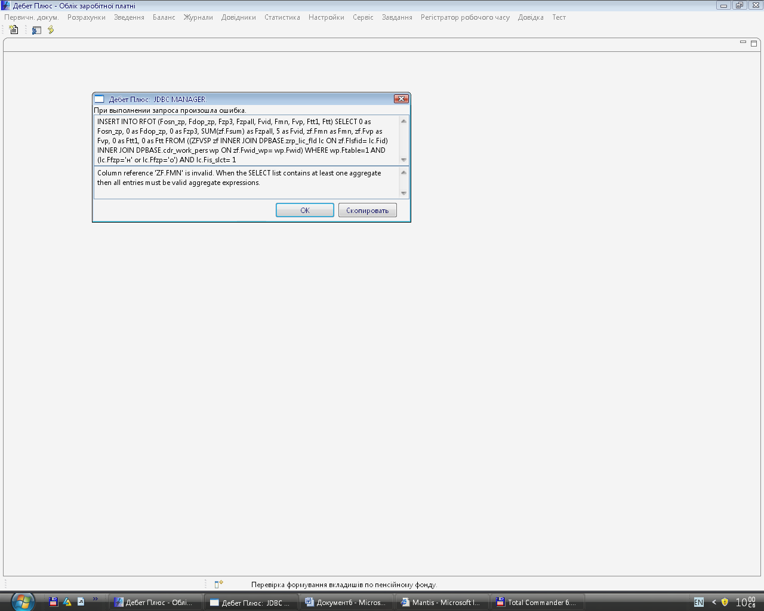
INSERT INTO RFOT (Fosn_zp, Fdop_zp, Fzp3, Fzpall, Fvid, Fmn, Fvp, Ftt1, Ftt) SELECT 0 as Fosn_zp, 0 as Fdop_zp, 0 as Fzp3, SUM(zf.Fsum) as Fzpall, 5 as Fvid, zf.Fmn as Fmn, zf.Fvp as Fvp, 0 as Ftt1, 0 as Ftt FROM ((ZFVSP zf INNER JOIN DPBASE.zrp_lic_fld lc ON zf.Flsfid= lc.Fid) INNER JOIN DPBASE.cdr_work_pers wp ON zf.Fwid_wp= wp.Fwid) WHERE wp.Ftable=1 AND (lc.Ffzp='н' or lc.Ffzp='о') AND lc.Fis_slct= 1

